# Week 11: Advanced Geometry Techniques & Product Data Management

|  |  |
| --- | --- |
| **Concepts** | * Advanced part modeling * Lofting * Importing and manipulating sketch picture * Sketching with splines * Embossing logo * Drawing a helix to make a spring * Using Branch/Compare/Merge features |
| **Models** | * Chopper Design complete |
|  | |

# Mini Chopper Continued

In this lesson, we are going to finish up the design of our Chopper, including some of the more advanced geometric features.

In doing so, we will use the loft feature to create the blade, we will import a picture, and trace over it in order to put a logo on the front of the Main Body, and we will create a spring by using the helix feature. At the end of this lesson, our chopper will be ready for assembly!

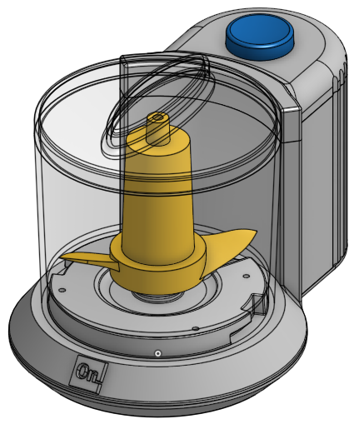

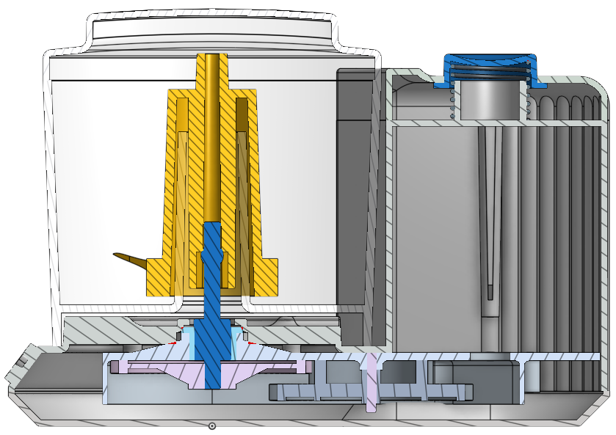

|  |
| --- |
| **Design Intent Check**: We’re going to start by making the Blade of our Chopper. Where is the Blade located? Could you guess how we’re going to make the two sharp blades? |

1. Start by creating a new sketch on the Front Plane, and name it “Blade Housing Profile”. Several features will be made from it, so it has some extra details. Several layouts are provided below. Note the tangent relationship between the fillet radius in the Blade Housing Profile and the swaged feature of the shaft:

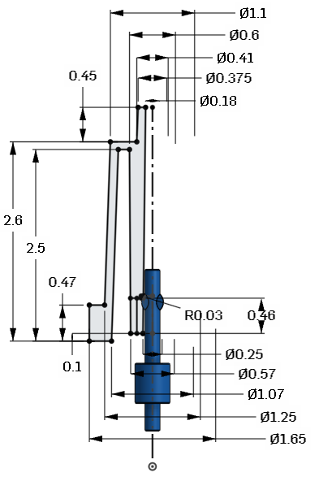

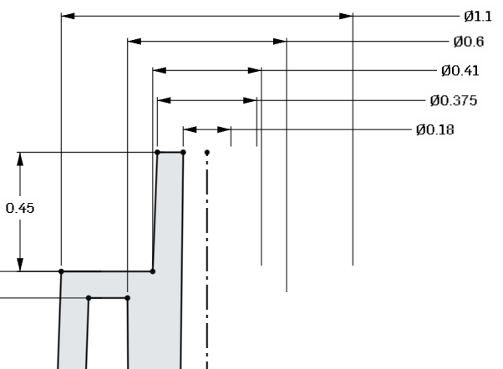

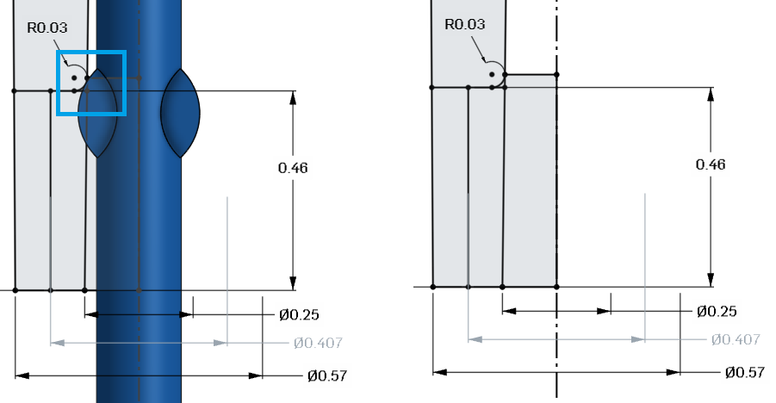

1. Next, create a new part by revolving the entire profile around. Rename the new part “Blade”:

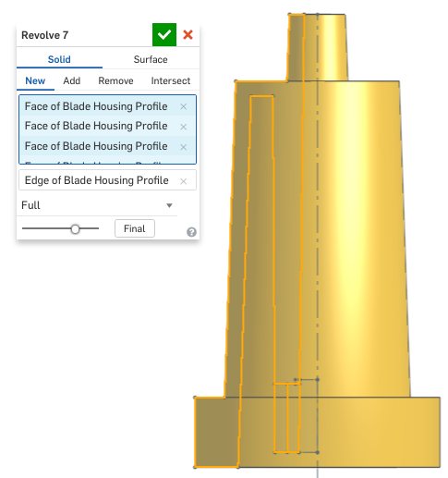

Here is a cross-section view for clarity:

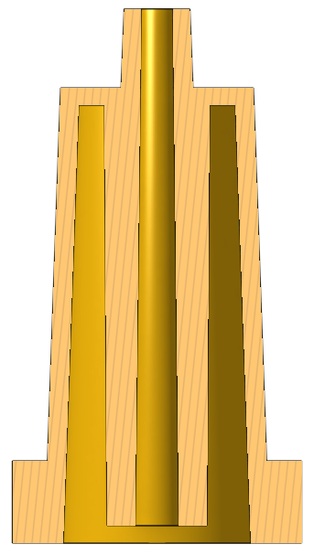

1. Next, we’ll create a Mate Connector for the Blade to help us in assembly. Use the top of the shaft as a reference for its location, but make sure that the Blade is the “Owner part.” In other words, use the grey shaft to locate the Mate Connector, but assign the blade as its owner part, so that the Mate Connector follows the blade wherever it goes.:

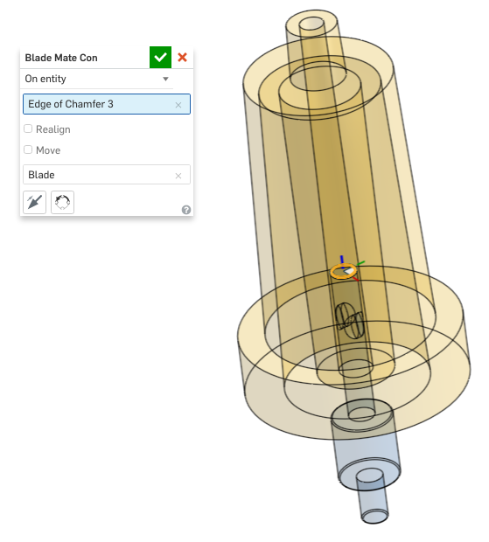

## Loft

We’ve created lofts before, but now we will use it to create the sharp blade for our Chopper. A Loft is a powerful tool which is commonly used to create advanced geometry like propellers, fan blades, and aircraft wings, where the cross section changes shape, size, and orientation. We will use that approach to create the blade, so we can see just how powerful it is. It may seem like our cross section sketches are overly complicated, but in reality, we are creating a robust framework to make sure we have full control over our blade profile.

1. First, create the following sketch on top of the outer surface of the Blade (the sketch plane is highlighted by the arrows). Note the addition of a sketch point at the midpoint of the arc:

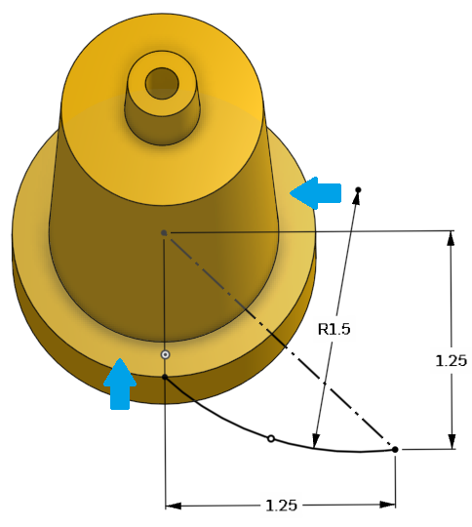

1. Next, we’ll create three planes. Each plane will be located at each of the three points on the arc above (both endpoints and the midpoint) and will also be perpendicular to the arc. Start by selecting the Plane Feature, then choose the “Curve Point”, and select the first point, and the curve:

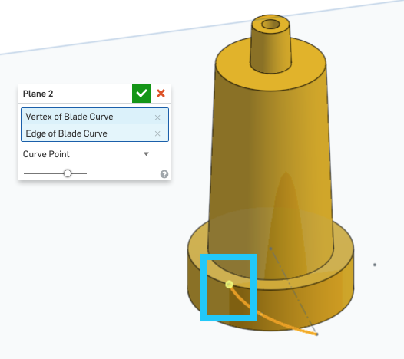

1. Repeat the process for the midpoint:

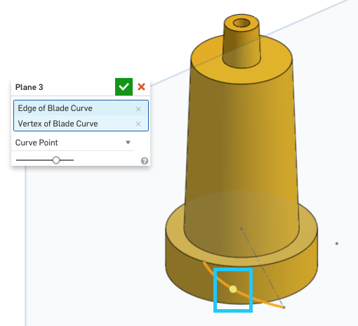

1. And repeat it one more time for the other end point:

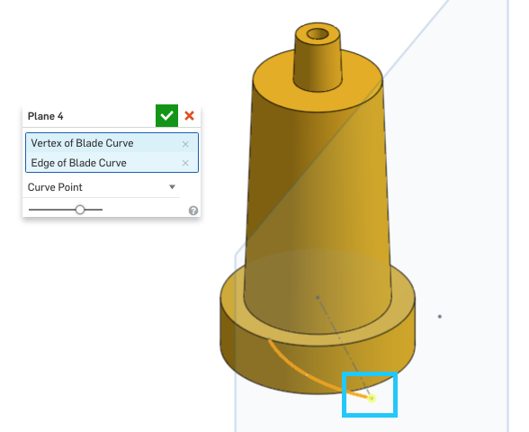

1. Before moving forward resize the planes to better fit the sketches that we will create:

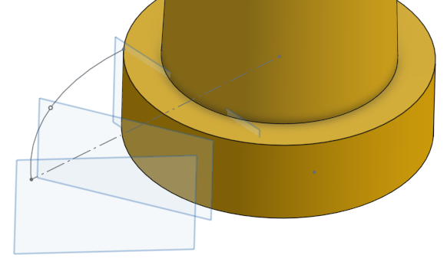

*Pro Tip: In this case, we are about to create several similar sketches near each other for our loft. In some cases, it is easy to get disoriented in our model. In reality, these planes are infinitely large, and so they intersect each other. However, resizing the planes in the graphics screen allows us to separate them and stay focused on the local geometry that we need to sketch/reference.*

1. Next, create the following sketch on the first plane (the one closest to the yellow rotor). Remember, use the “n” key on the keyboard to orient the sketch normal to the screen. Note that the vertical construction line is constrained to the first point of our sketch. Name this sketch “Blade Profile 1”:

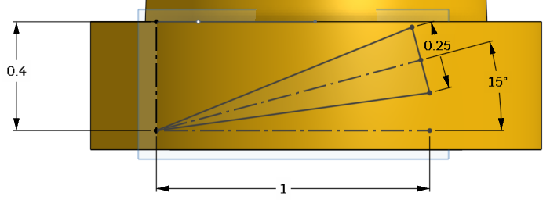

1. Next, on the second plane, create the following sketch. Note that the vertical line sketch is constrained to the midpoint of our curve. Name this sketch “Blade Profile 2”:

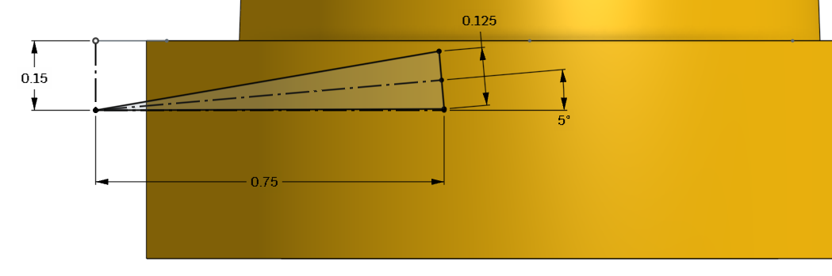

1. Next, on the third plane, create the following sketch. Note that the vertical line sketch is constrained to the final end point of our curve. Name this sketch “Blade Profile 3”:

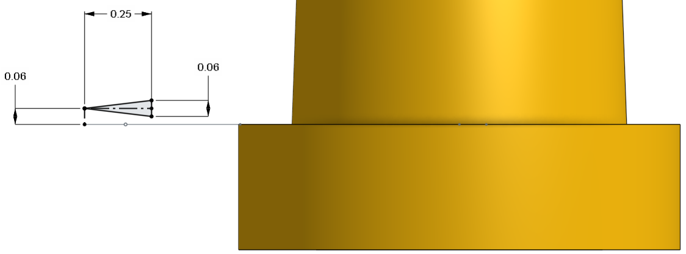

*Pro Tip: Notice how we added three “extra” construction lines in each of our sketches. In this case, we are only creating a triangle, however, with this type of lofted geometry, we want to have specific control over the size, and rotation of our triangular cross section. This will allow us to fine tune the profile. The vertical and horizontal construction lines are used to “size” our triangle, and the third construction line is used to specify the angle of rotation (except for the third profile, which is horizontal). The only other dimension we need, then, is the width of the trailing edge of our profile.*

*This might seem like extra work, but it will pay dividends in the future, when we want to fine tune our design. Note the transitions between each sketch:*

*Height: 0.4” (down), 0.15” (down), 0.06” (up)*

*Width: 1.0”, 0.75”, 0.25”*

*Angle: 15°, 5°, 0°*

*Trailing Edge: 0.25”, 0.125”, 0.06”*

*This could easily be put into tabular form, and documented. Approaching your CAD model in a methodical manner will save lots of time and headache in the future during design updates. Good job, this is an advanced approach!*

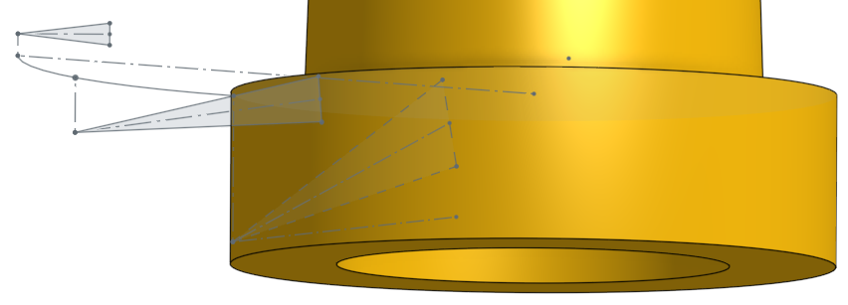

1. Next, create the loft, by selecting the sketches in the proper order. Rename the feature to “Blade Loft”:

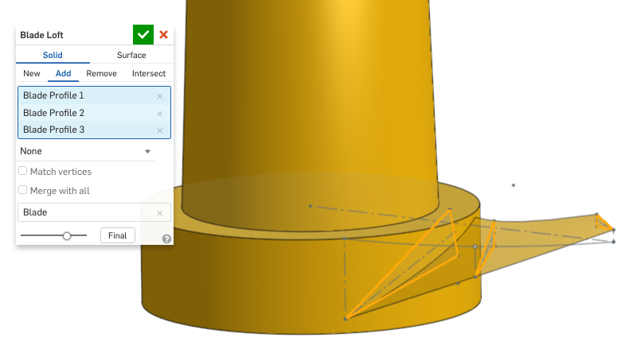

*Pro Tip: Another, more advanced, way to change the way the blade is shaped is to use a “guide curve”. Guide Curves will actually “guide” the profile of the loft in between each profile. Since the Loft needs to reference the profiles and the guide curve, it is critical that the guide curve intersects the profiles, otherwise the loft won’t work. To add a guide curve to our existing loft we need to do several things:*

1. *Roll back the model to just before the Blade Loft (Blade profile 3):*

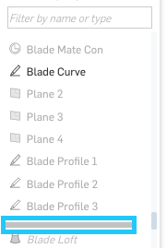

1. *Add a plane (called “Guide Curve Plane”) that goes through the three endpoints of our profiles (highlighted in blue):*

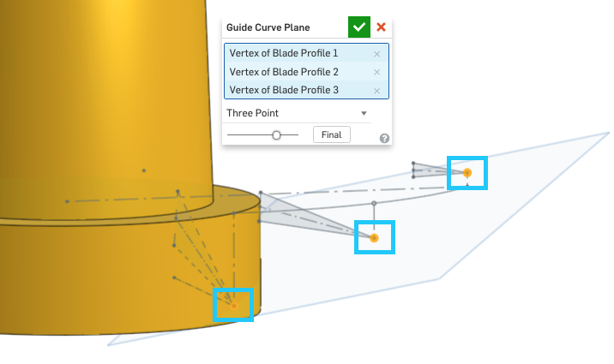

1. *On that plane, create a new sketch (called “Guide Curve”) that is a single arc which passes through those same three end points (highlighted in blue) using “coincident” constraints. Note how the leading edge does not align with the guide curve in this picture:*

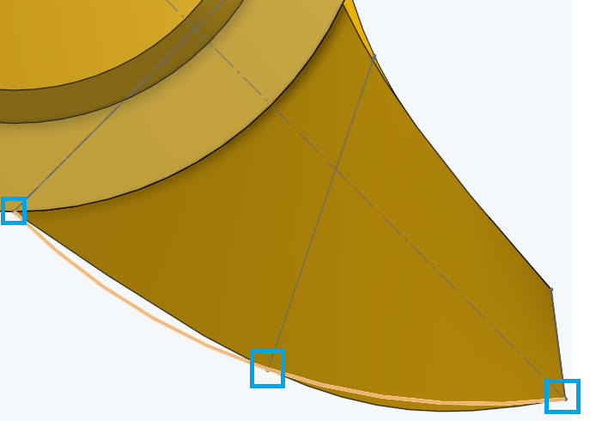

1. *Edit the Loft, and use the “Guides” option to select the Guide Curve. Notice how the leading edge of our loft now aligns with our guide curve!*

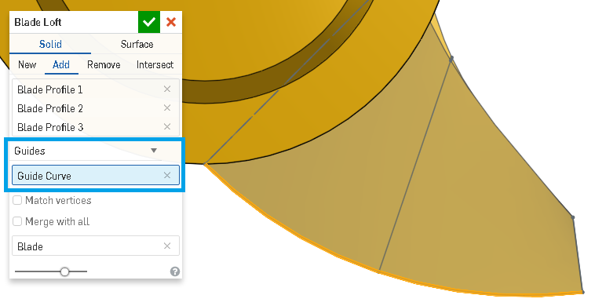

1. *Here’s the new Blade Loft, showing all of the sketches involved in creating it:*

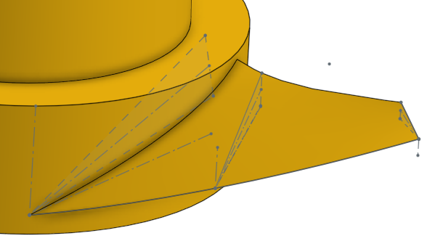

1. *Here’s the same Loft with a more drastic guide curve. Try it yourself! The key is: the guide curve MUST go through those three points, using Coincident constraints.*

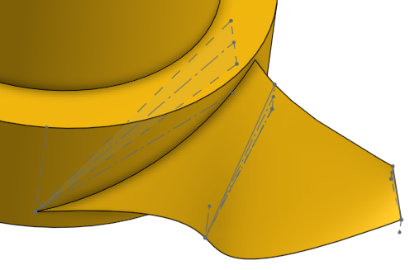

*This may be appear to be a subtle change with this Mini Chopper, but with highly engineered structures, like in aerodynamics, these subtle changes can be all the difference in a parts performance or reliability. Using Guide Curves with our loft is an advanced method because it involves attention to detail and the ability to really visualize the geometry in 3-dimensions in your head. As your skillset goes up, so does the complexity, but approaching it in a methodical manner and being organized are the best ways to do it. And, the reward is very much worth it!*

1. Next, let’s add a fillet to the trailing edge of the blade:

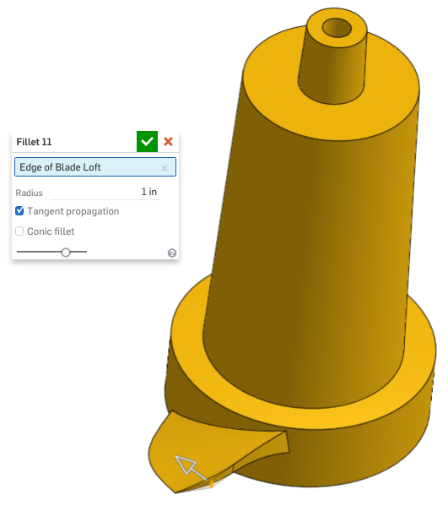

1. Next, create a second blade by patterning it around the center of the Blade Housing Profile Sketch:

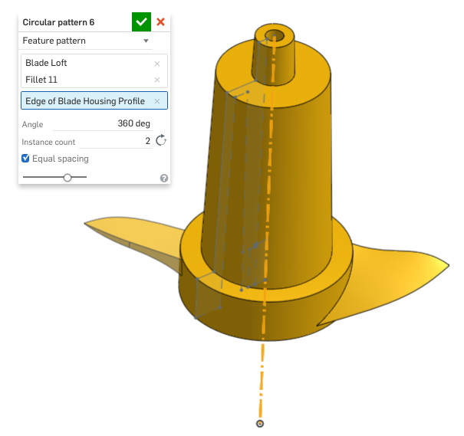

1. Next, use part of the Blade Housing Profile sketch to extrude out a slot in the center of the Blade. Make sure to select three sketch regions:

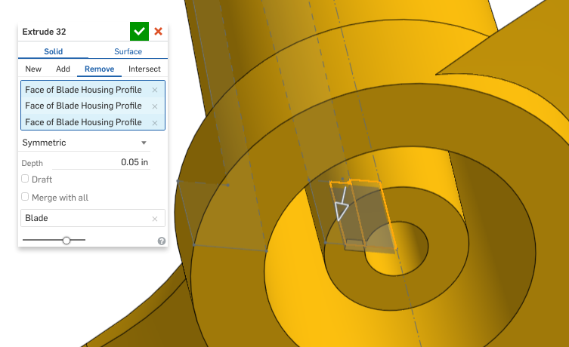

1. Next, finish the Blade part, by mirroring the slot across the Right plane:

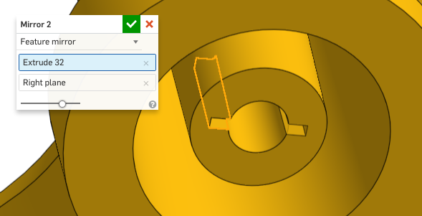

1. That finishes up the geometry for our Blade part. Here is a cross-section of the part, make sure your part looks like this before moving on:

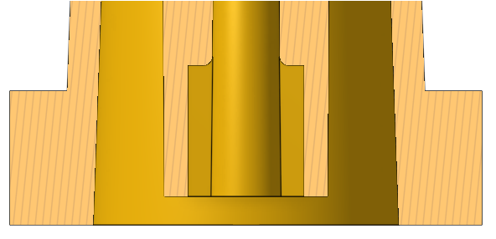

## Sketch Picture

|  |
| --- |
| **Design Intent Check**: Now, we’re going to be adding a logo to our Base. The extruded logo will be curved just like the Base surface. How do you think we will achieve this? |

## 

Sometimes we want to bring in a sketch picture and trace over it. This happens often, when we want to mold the name of our company, or our brand logo into our plastic parts. This is easily done in Onshape with a simple three step process:

1. Upload the picture file into a new tab
2. Insert it into a sketch
3. Trace over it using any and all of the sketch tools available to us

We can even make the graphics “perfect” by taking advantage of constraints and symmetry. We will walk through it now, but more info can can be found in the Onshape help here: <https://cad.onshape.com/help/#sketch-image.htm>

1. Start by creating a new plane that is perpendicular to the Front plane, and passes through the small edge in our Profile Sketch. Make sure to select the edge before the plane. Rename the plane “Emboss Plane”:

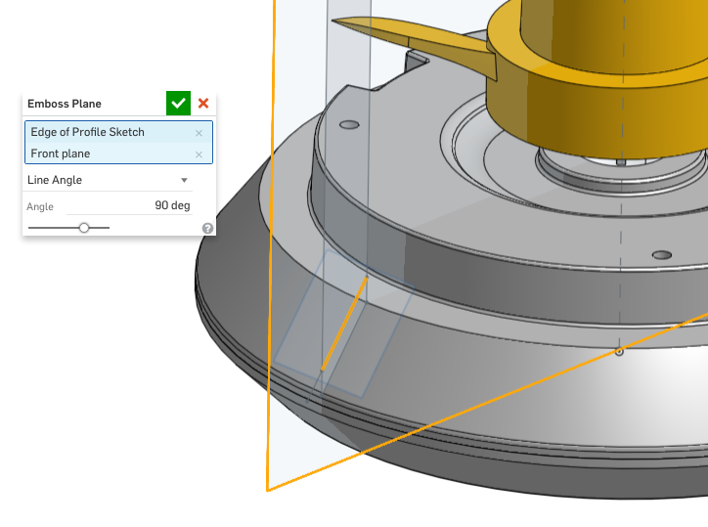

1. Next, let’s upload our logo file (+ sign, then Import). In this case, it’s going to be the Onshape Logo, although any logo may be used:

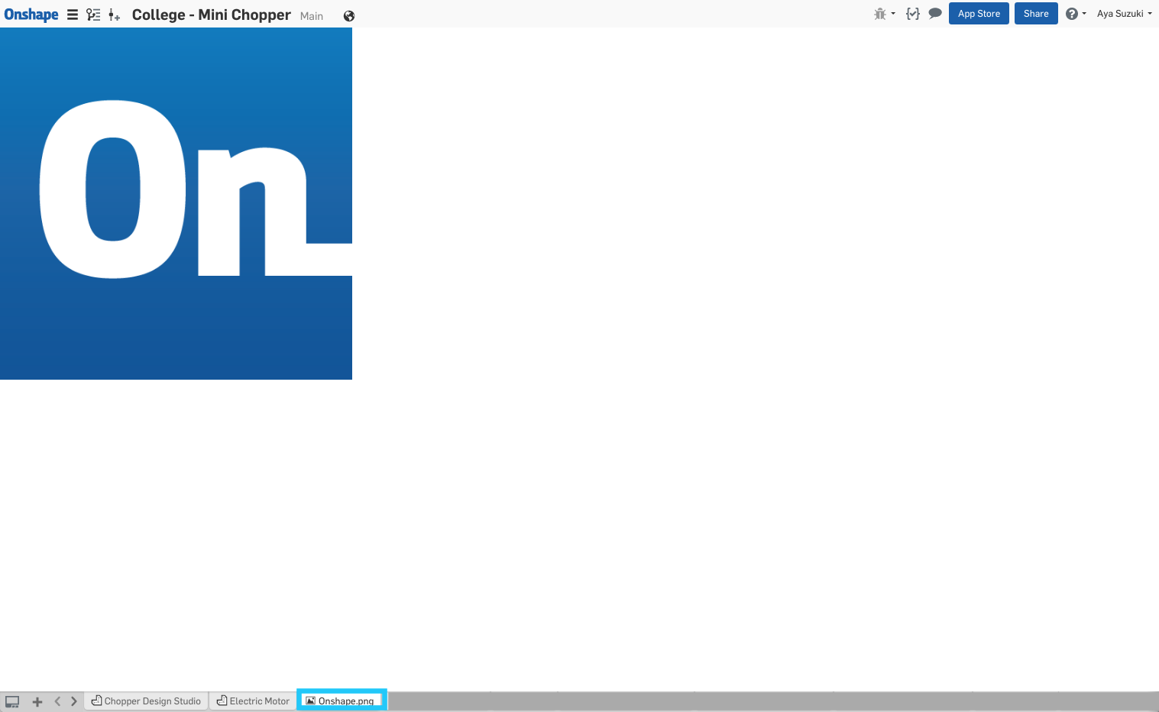

1. Next, create a new sketch on this plane (don’t forget to use the “n” key to make the sketch normal to the screen). From the sketch menu, select “Insert Image” from the sketch toolbar:

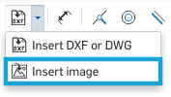

1. Select our newly uploaded logo file. Note that you must first import an image for it to show up here:

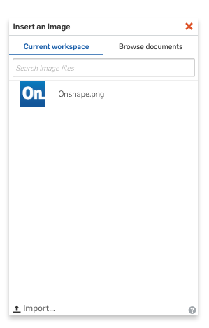

1. Next, draw the bounding box of the image to place and size it. This is just like drawing a rectangle:

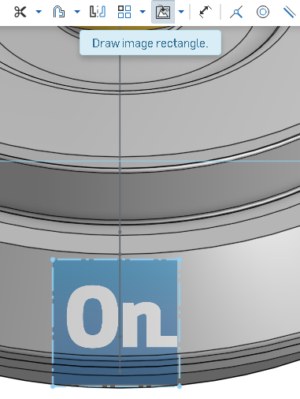

*Pro Tip: If your logo is reversed, check to make sure that you selected the edge before the plane in the Emboss Plane feature in Step 18.* *Planes have directionality, which doesn’t matter in most scenarios, but does here.*

1. Next, using sketch constraints and dimensions, fully define the sketch as shown here. Note that the vertical construction line references the origin:

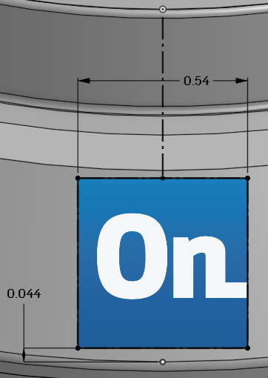

1. Next, using sketch tools (likely splines),trace over the letters of the logo. It is not critical to have the logo sketch fully dimensioned (more a matter of personal preference). In this case, the sketch has been manually dragged into place, and then all of the sketch entities have been fixed in place using a Fix constraint:

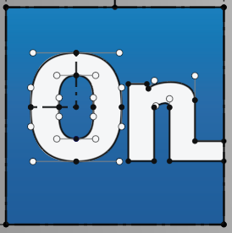

## Sketch Spline

In this particular logo, sketch splines were used to get the curvy profiles of the “O” and the “n”. Splines are a unique kind of curve, because unlike an arc, they do not have a constant radius. Instead, splines are made up of “points” and “tails”. The points control where the spline goes, and the tails control how it gets there. Here’s an example of a simple 2 point spline on our “n”:

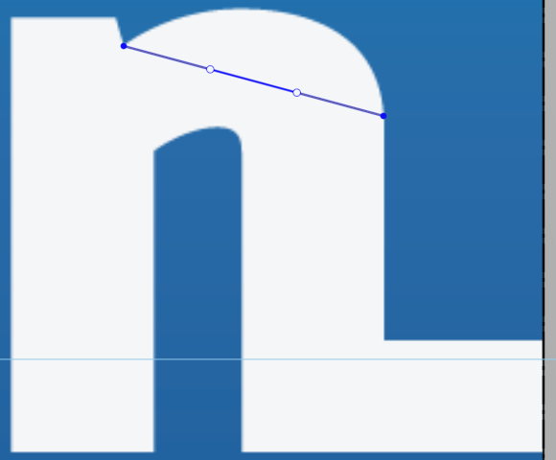

Here we have two spline points (in blue), and two tails (whose endpoints are in blue/white). By dragging the left tail end point upwards we see the spline take shape:



And by dragging the right tail end point upwards, we can trace over the top of our “n”:



The end point of the tails can even by constrained. By adding a “vertical” constraint between the right spline point and the right tail end point, we can ensure that the spline is vertical there (constraint shown highlighted in orange):



Finally, we can just drag the tails a little bit more to get the perfect fit:

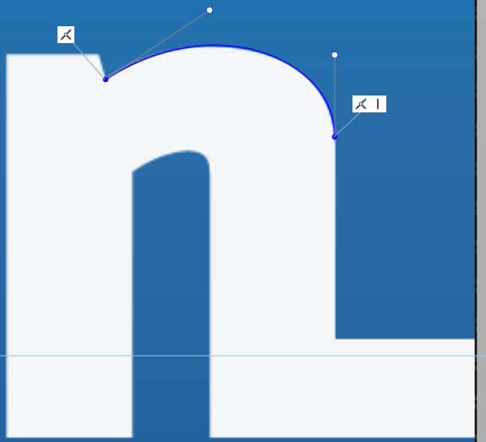

This looks great! If the spline needs to be more complex, just add more spline points by clicking the spline point tool and selecting the sketched spline:

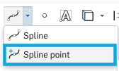

Another useful tool is the Spline Point, which allows you to add additional points along the spline after the spline is already created. More info on splines can be found in the Onshape Help here: <https://cad.onshape.com/help/#sketch-tools-spline.htm> and for spline points, look here: <https://cad.onshape.com/help/#sketch-tools-splinepoint.htm>.

1. Next, extrude the sketch up to the outer surface of the Main Body, including draft:

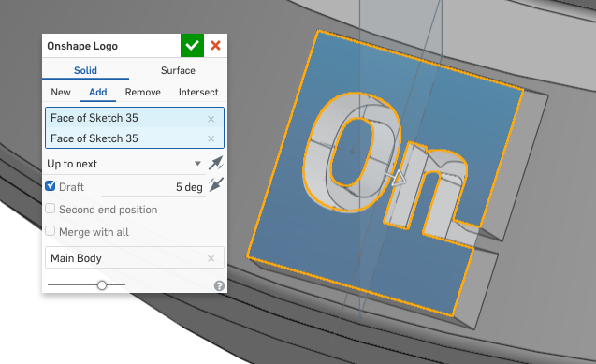

1. Right now, our logo has a flat face. Let’s try to round the logo face like the surface of the chopper’s Base. Using the original Profile Sketch as a reference, revolve a surface symmetrically around our logo:

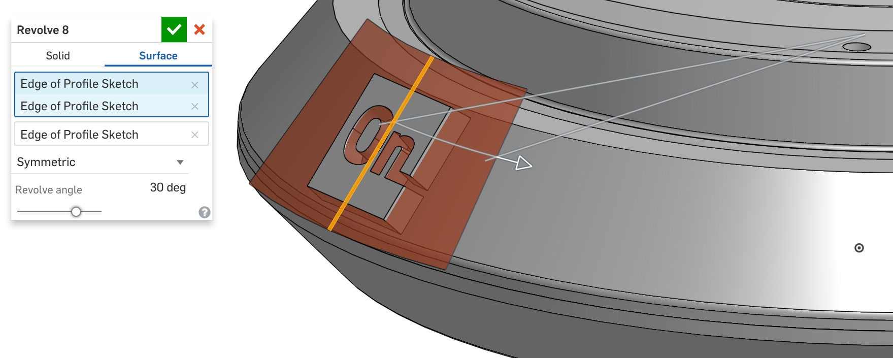

1. Next, use this new surface to trim the logo:

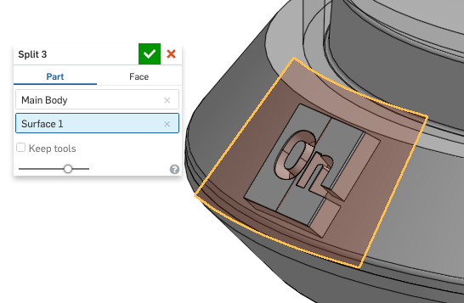

1. After the split, there will be 3 very thin parts created on top of our logo. Use the “Delete part” feature to remove them from our design:

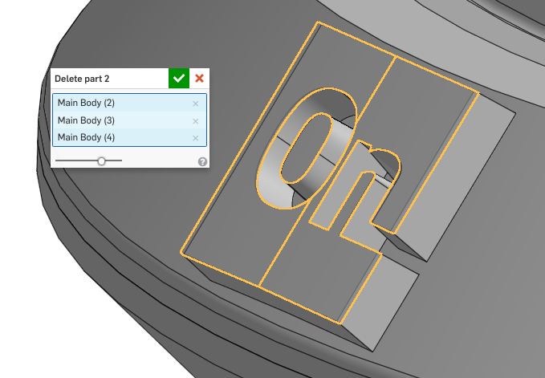

1. Now that we have finished our logo design, the geometry should look like this:

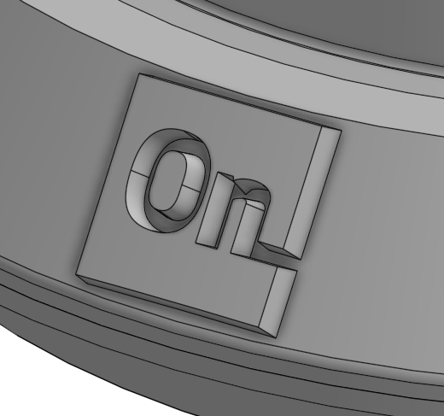

## Emboss Text

Let’s take a moment to reflect on what we just did. The previous workflow is a common approach with an “embossed” text or logo. You may notice it from before, but this particular application is popular. It involves these steps:

1. Sketch the text/logo
2. Extrude it up to the part surface
3. Trim it back using another surface
4. Delete the trimming surface (optional)

Similarly, instead of trimming the surface, you could just extrude it in two directions between two offset surfaces. Don’t forget to include draft in the extrude, so the emboss feature can be drafted. This approach works with the emboss both extruding out of the part (like we’ve done here) or sunk into the part like this:

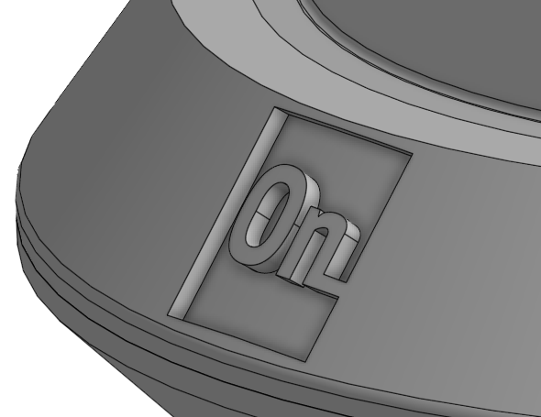

|  |
| --- |
| **Design Intent Check**: We’re going to be making a hollow button that will be on the Top of the Chopper. How does it fit with the Top? How can we make it hollow? |

1. Next, we are going to create a button for our chopper. Just like the cover to our Bowl and our embossed logo, we are going to utilize a surface for this. Start by creating a hole for our button, by referencing our original Layout Sketch. Note that the scope for this feature is just the “Top” part:

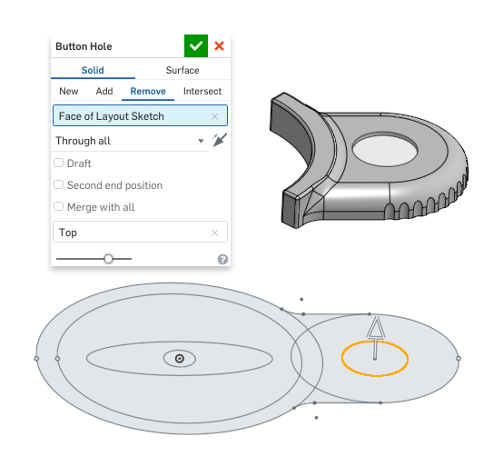

1. Next, sketch the profile of the button. The vertical construction line references the center of the hole in the original Layout Sketch:

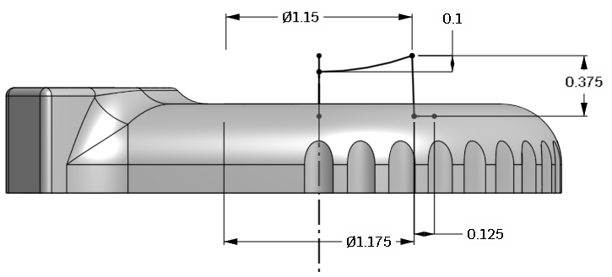

Here’s a section view for clarity:

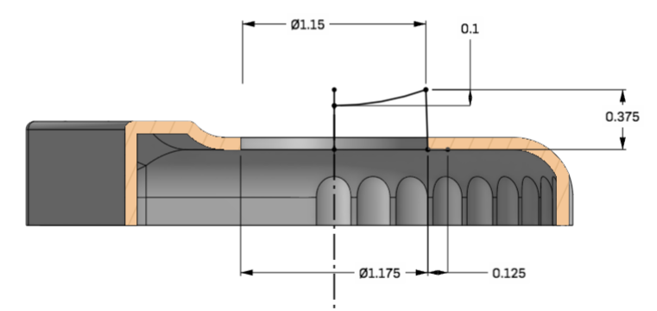

1. Next, revolve the button profile around. The Top part has been made translucent for clarity:

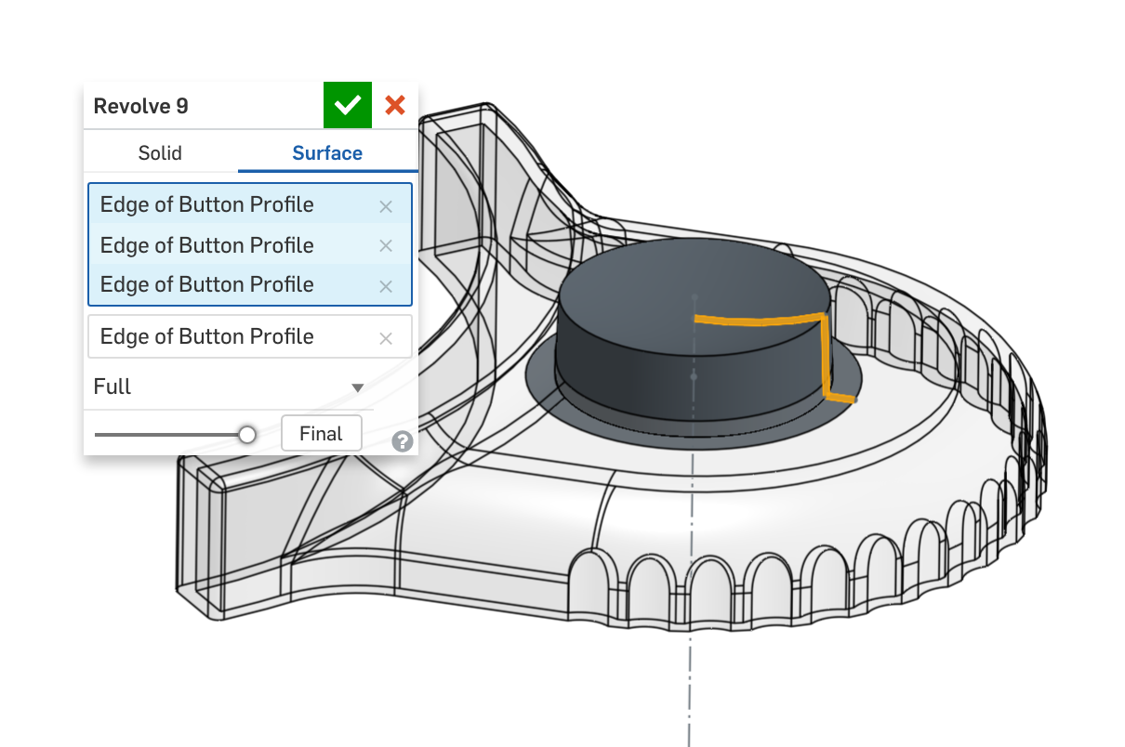

1. Next, add a fillet to the top of the button (This could also have been sketched in the profile):

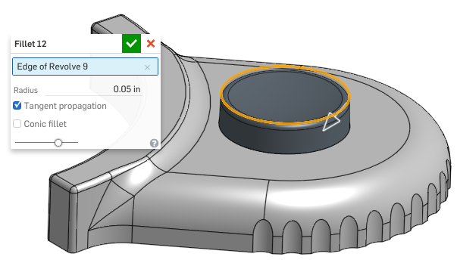

1. Next, thicken the surface inwards, and name the new part “Button”:

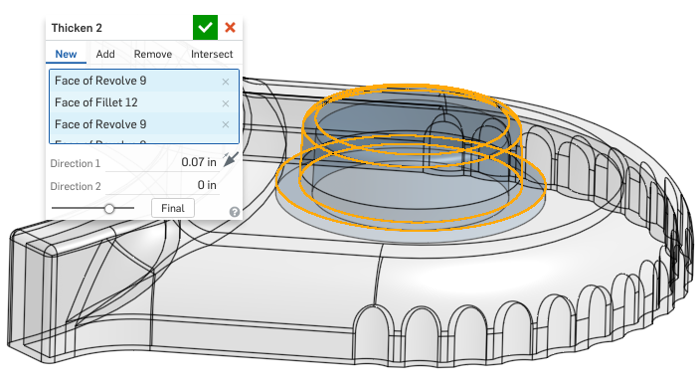

1. Next, delete the surface part (as it is not needed anymore):

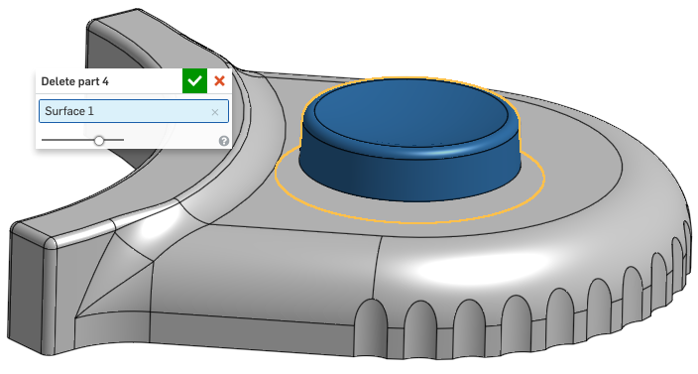

1. Next, we’re going to create the boss which holds the button spring in place. Start by creating the following sketch on the top surface of the Main Body part:

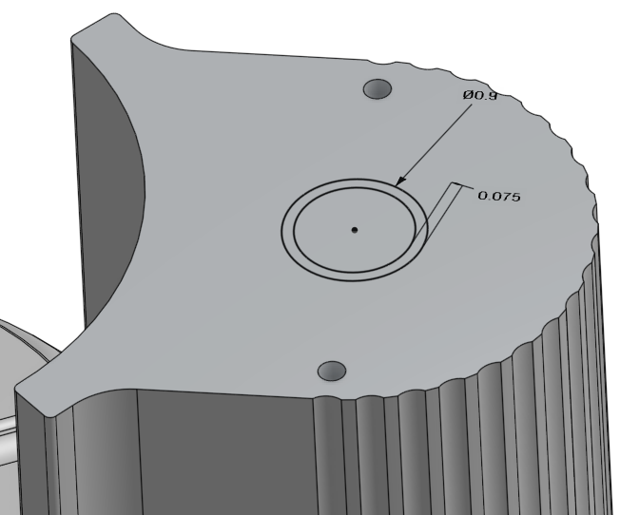

1. Next, extrude it upwards:

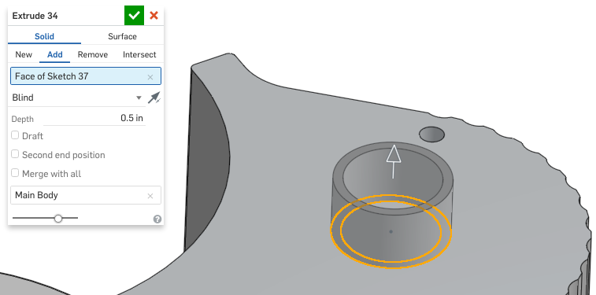

## 

## Helix/Spring

|  |
| --- |
| **Design Intent Check**: Now we’re going to be adding a spring below the Button. Think about why we’re adding a spring and where it should be placed relative to the Button. Any ideas on how to make the helix? |

## 

A popular type of geometry to create is a spiral/helix, and the most common uses for these are threads or springs. Modeling threads is becoming more common as 3D-printing custom parts is becoming more popular; however, adding threads is still relatively rare compared to how many threaded parts we use (screws, nuts, bolts, etc). Creating a spring is very popular, because many springs are custom, so creating an accurate 3D model/drawing for manufacturing is critical. In Onshape, this is a simple three step process:

1. Create a helical curve
2. Sketch the cross-section
3. Sweep the cross-section through the curve

We’ll walk through the creation of a spring next. For more information on helices, see the Onshape Help here: <https://cad.onshape.com/help/#helix.htm>.

1. Let’s start by creating a cylindrical surface. Sketch the following line on the Front Plane (The Button and Main Body parts have been made translucent in the first picture, and removed completely in the second picture for clarity):

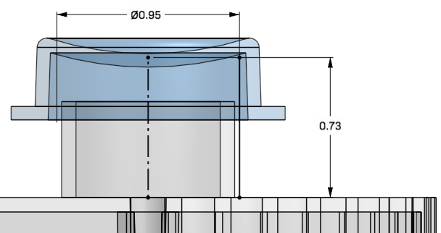

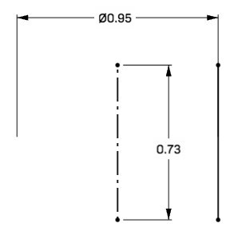

1. Next, revolve the line around to create a surface:

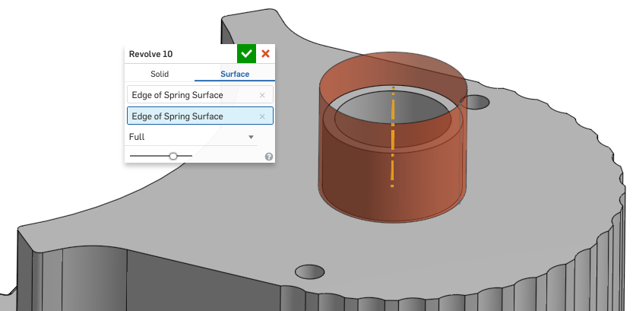

1. Next, use the Helix feature  to create the following helix on our surface:

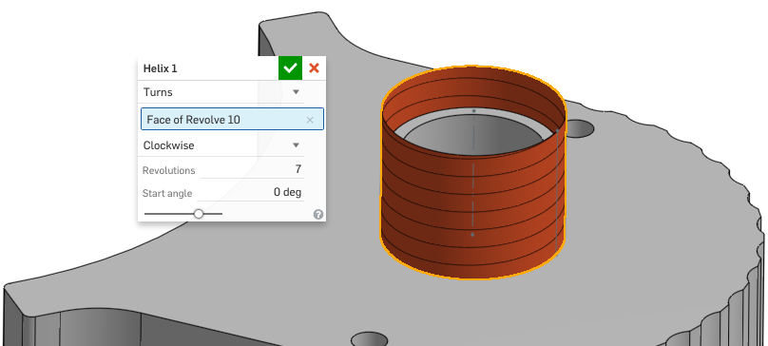

1. Next, sketch the cross section of spring - a small circle on the Front Plane. The circle should be coincident with the end point of the helix as shown:

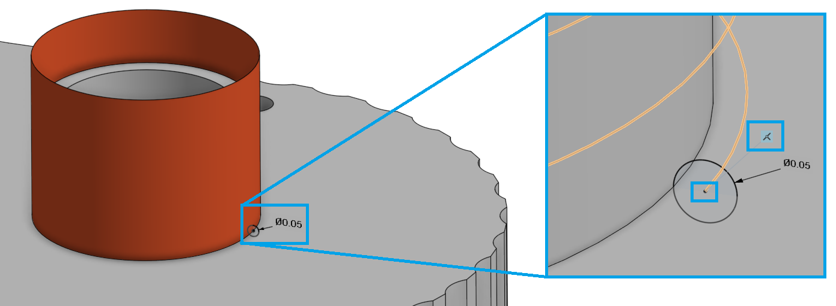

1. Next, sweep the cross section of the spring through the helix:

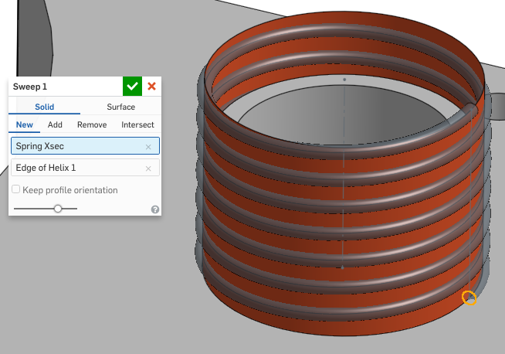

1. Finally, delete the surface part as we don’t need it anymore:

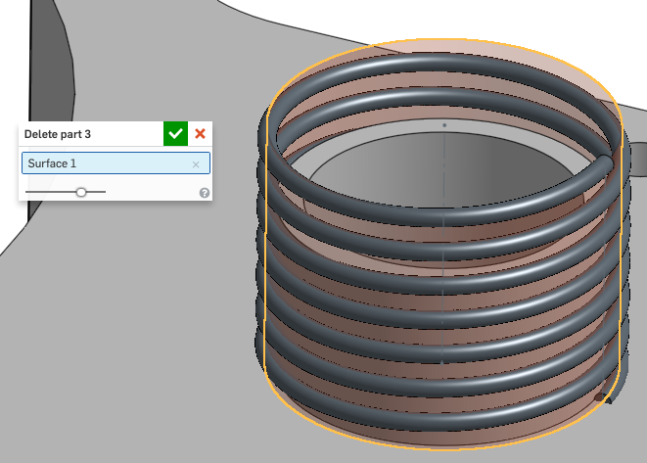

1. Now that we have completed a lot of advanced geometry techniques, let’s create a Version called “V3”. The final Spring & Button geometry should look like this (the Top part has been removed for clarity):

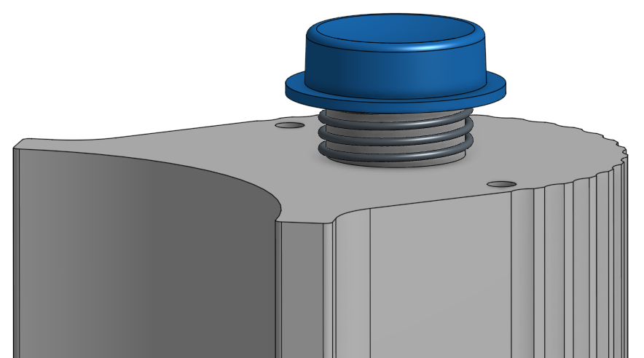

## Concurrent Design

It is quite common for a design team to try different ideas at the same time. The industry has several names for this process, such as “Concurrent Design”, “Concurrent Engineering”, “Simultaneous Engineering” or “Integrated Product Development” and it occurs when multiple versions of a design are pursued in parallel to each other during the development process. This is typically very difficult with most CAD systems and requires expensive PDM (or Product Data Management) systems. The process goes something like this:

Step 1: A baseline design is chosen.

Step 2: Multiple versions are “**Branched**” off from the baseline, and pursued in parallel. In a company, this requires dividing up design resources.

Step 3: After pursuing multiple versions for some time, the multiple versions are “**Compared**” to each other. Ultimately, a winner is then chosen. The winner may be one of the previous versions, or, most often, it may be an even newer version, which has “**Merged**” multiple design elements from each of the previous versions.

Step 4: The design resources are refocused on the winning product design, and development continues.

Since Onshape is 100% in the cloud, and does not have (or need) a formal PDM system, managing multiple design versions at once is quite simple. Onshape has made this process easy with its “Branch”, “Compare”, and “Merge” functions built right in. Let’s go through it first hand with our Mini Chopper, using our V3 Version as a baseline design.

### Branch

1. First, let’s rename our V3 Version to “Baseline”, for reference. Click on the gear icon, select “Properties...”, and rename it:

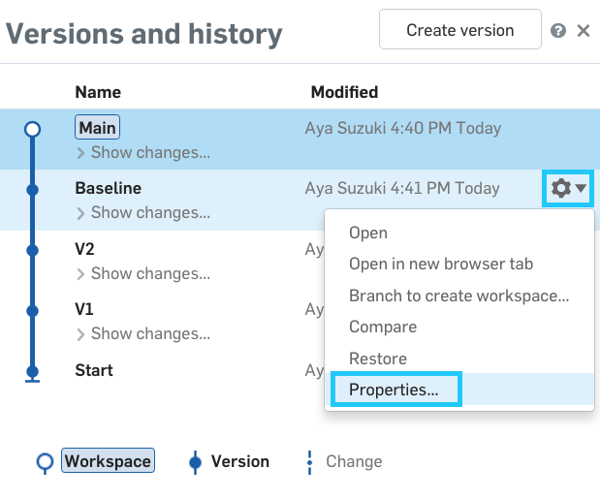

1. Next, click on the gear icon next to our Baseline Version again, and select “Branch to create Workspace”:

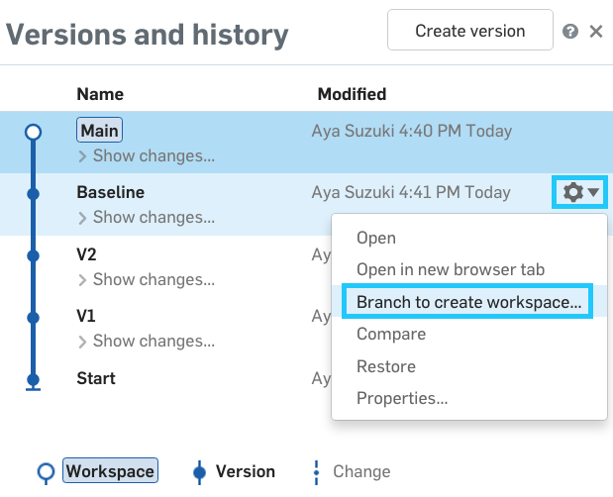

1. Let’s name this new Version “Design 1”, and click Create. This will create a new workspace, starting from the version “Baseline”. If we open the versions and history flyout, we can see this new “branch” visually:

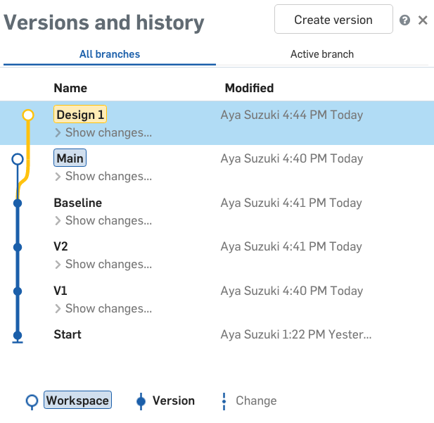

1. Let’s create another branch from the Baseline, which will represent our second design variation. Again, click the gear icon next to our Baseline Version and select “Branch to Create Workspace”:

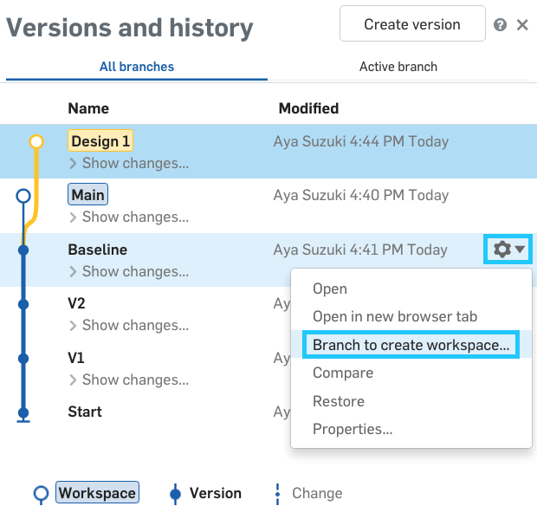

1. This will be called “Design 2”. After we create it, we should get a versions and history flyout that looks like this (Note that both Design 1 and Design 2 branch off of our Baseline Version):

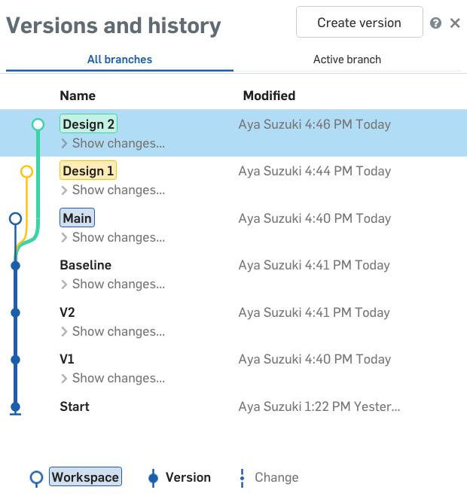

1. Now, let’s work on Design 1. Click on Design 1 to make it the active Workspace, and let’s update the bowl from 3.35” to 5” tall (via the Bowl Profile Sketch):

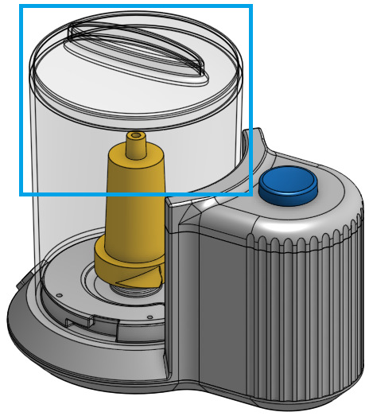

1. In addition, our versions and history flyout should now look like this (Design 1 is now at the top, because it has the most recent changes made to it):

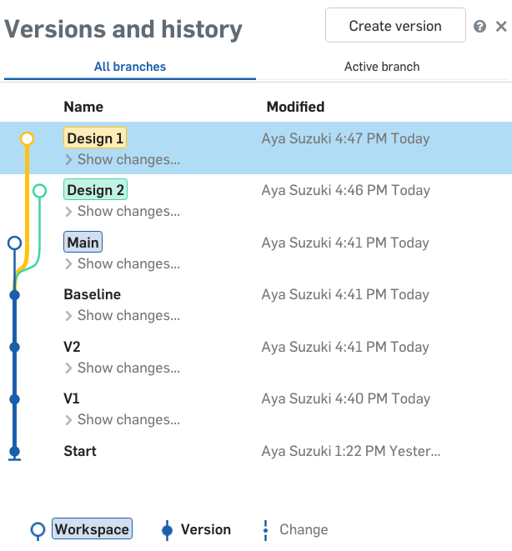

1. Next, let’s click on Design 2, and pursue another design change. This time, let’s make the bowl larger in diameter. To do this will take two changes. First we’ll update the major diameter of the design from 5.125” to 5.625” (via the Layout Sketch), and we’ll also update the diameter of the bowl from 4.25” to 4.75” (via the Bowl Profile Sketch):

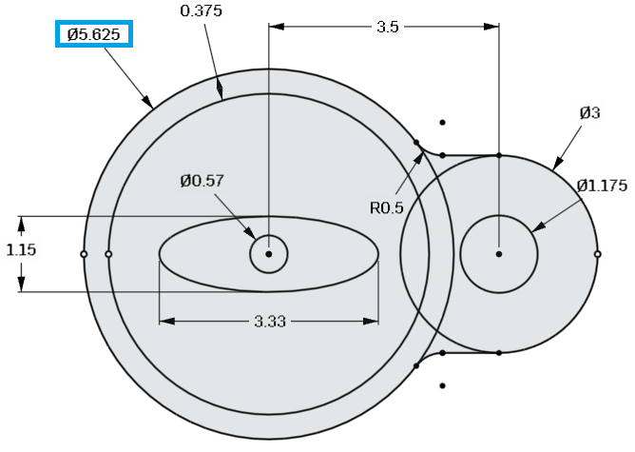

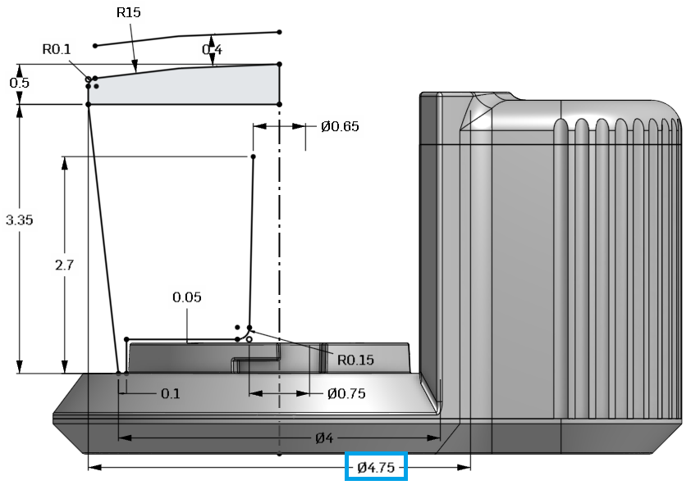

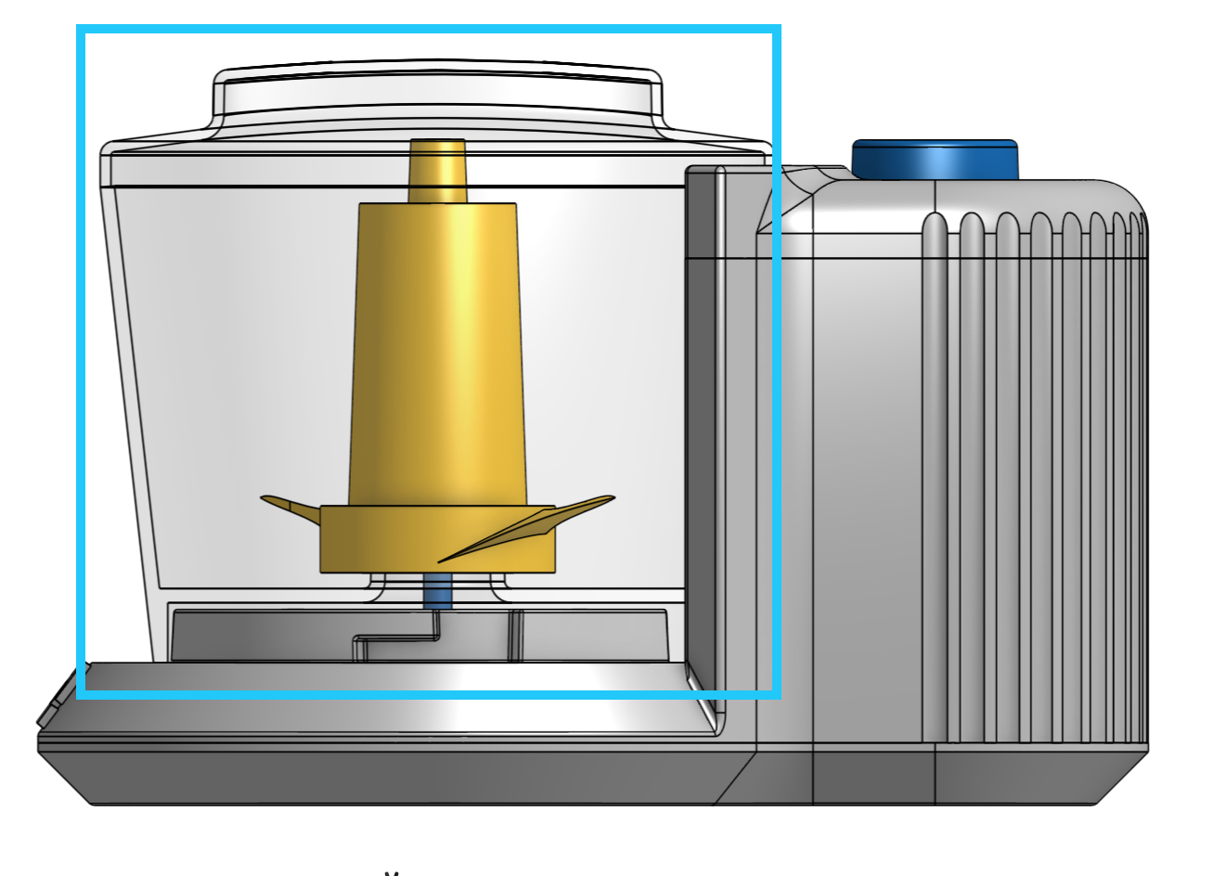

1. In addition, let’s change the design of the cover to incorporate a chamfer, instead of a fillet. For this we’ll need to remove the fillet, and create a .05” X 45° chamfer at the same point in the feature list, like this:

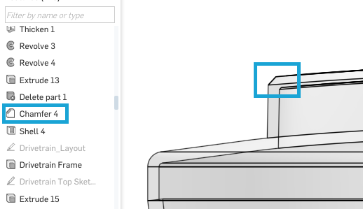

1. And if we review the versions and history flyout, it should now look like this (with Design 2 at the top now, since it has the most recent changes):

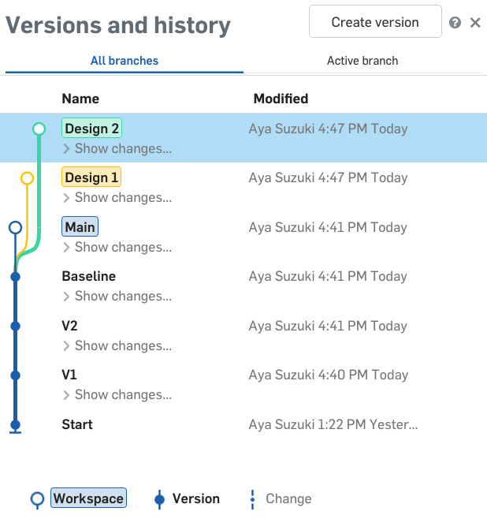

*Pro Tip: As you can see, these are two relatively simple design changes. However, each design is completely independent of each other, and in the real world, the changes may be much more complex. Take some time to double check that (1) the Baseline Version has been left exactly how it was before we made any branches, and (2) the feature lists for each design are completely independent of each other. If any work is done on the Baseline version, it will not propagate to the branches. To do this, you can click “Show changes” and see what was done in each branch.*

### Compare

1. Next, let’s compare Design 2 with Design 1. Using Onshape, we can do this very easily. While we are active in Design 2, click on the gear icon for Design 1 and select “Compare”:

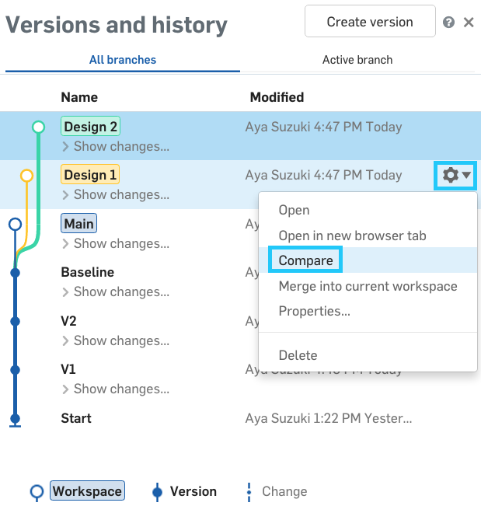

1. Now, both designs will be loaded into the workspace on top of each other. On the left side we can see the differences in the feature list:

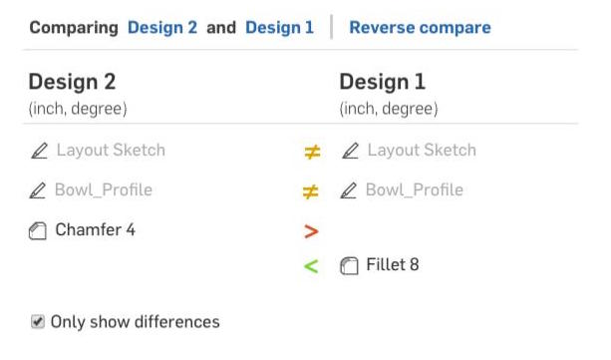

1. On the right side of the screen, we see the differences graphically. Note the slider, we can actually dynamically slide between Design 2 and Design 1. In our case, we are showing the tall bowl from Design 1 in red, and the wider bowl from Design 2 in blue (the fillet in Design 2 cannot be seen, however):

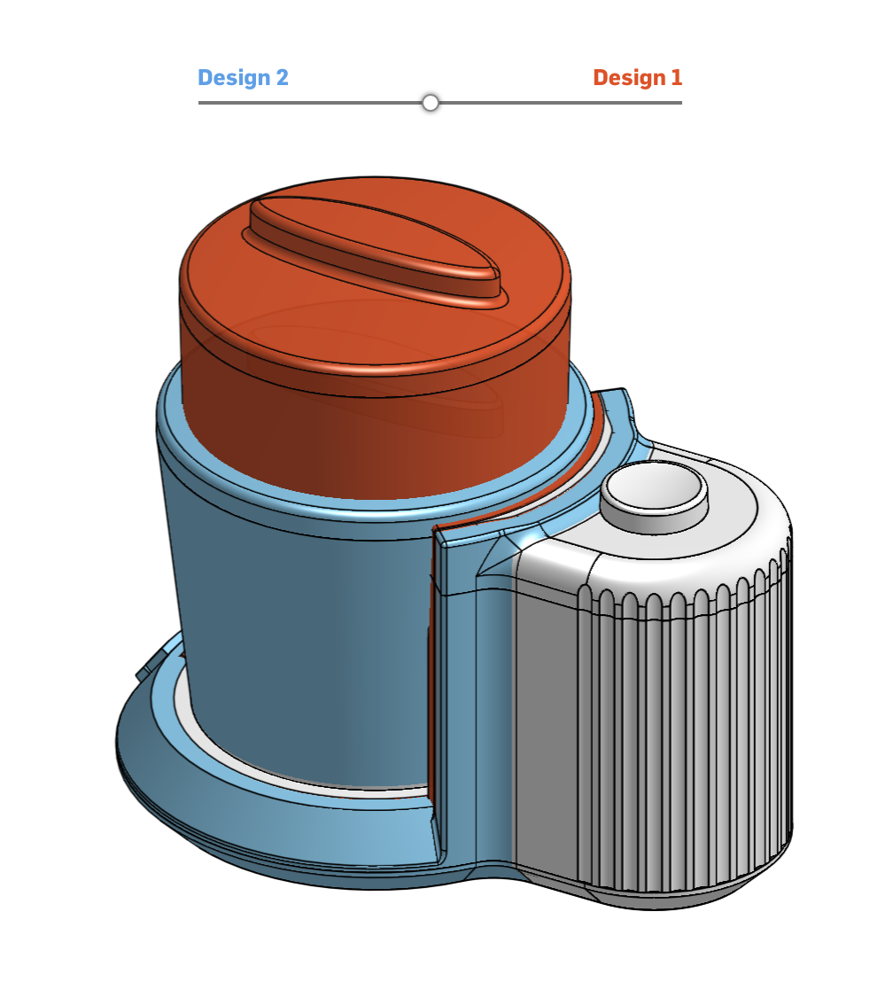

1. In the upper left-hand corner, we see links for Design 2 and Design 1. Let’s go back to Design 2, by clicking on it:

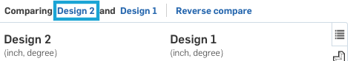

For information, see the help on Compare here: <https://cad.onshape.com/help/#compare.htm>

### Merge

1. Now, as we compared our designs, we realize that we like both of them! If we wanted to bring together the changes from both branches in another CAD system, you would have to tediously redo the changes by hand in a single part file. But here, the next step is to merge both designs into the Main workspace. First, select the Main Version, so it becomes the active workspace (The name of the active workspace is also located at the top of the screen, just after the document name):

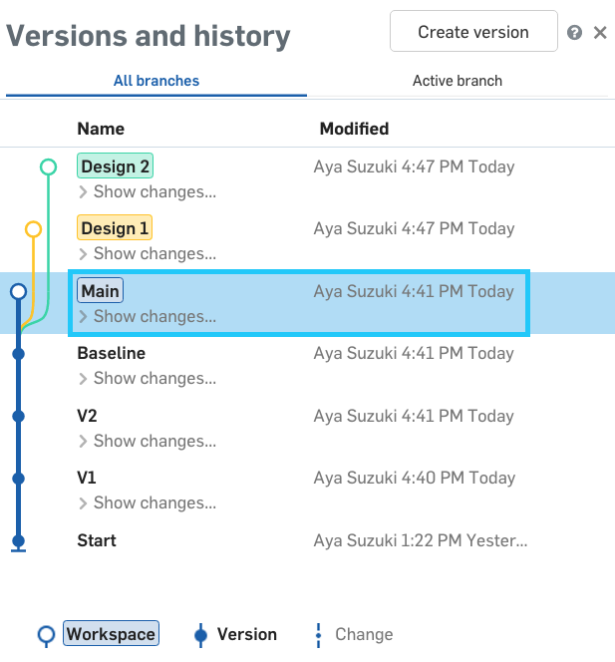

1. Next, click on the gear icon for the Design 2 Version, and select Merge into current Workspace:

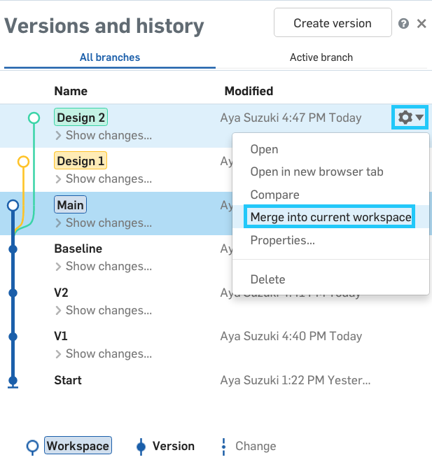

1. The Main Version should now look like this (just like the branch of Design 2):

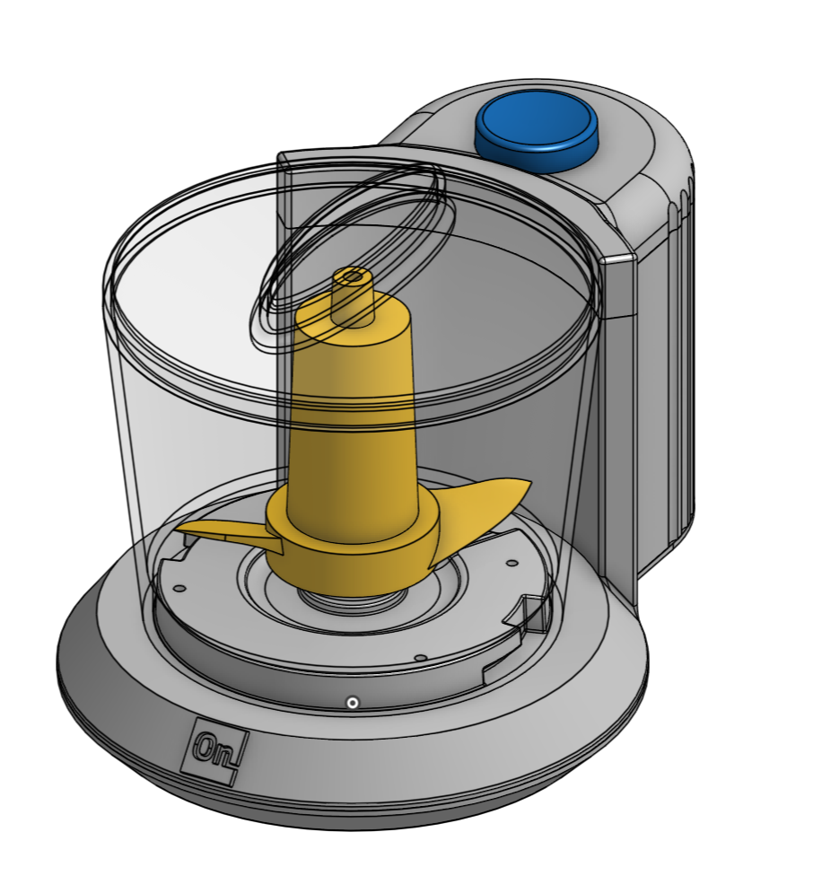

1. Now, let’s merge Design 1, using the same technique:

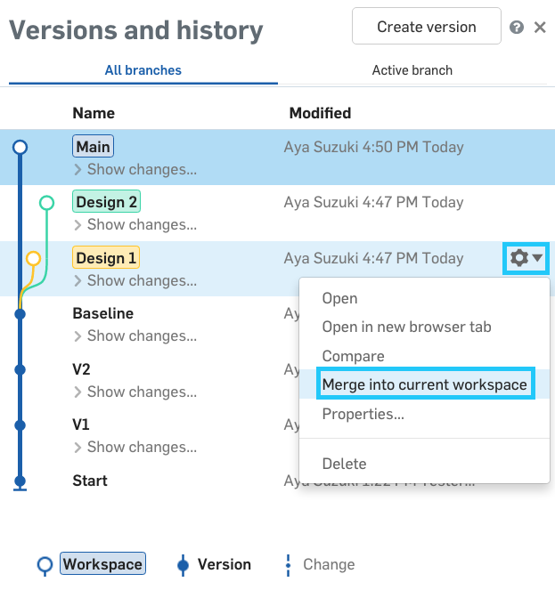

1. Now, the Main Version should look like this (showing the features from both Design 1 and Design 2 combined together):

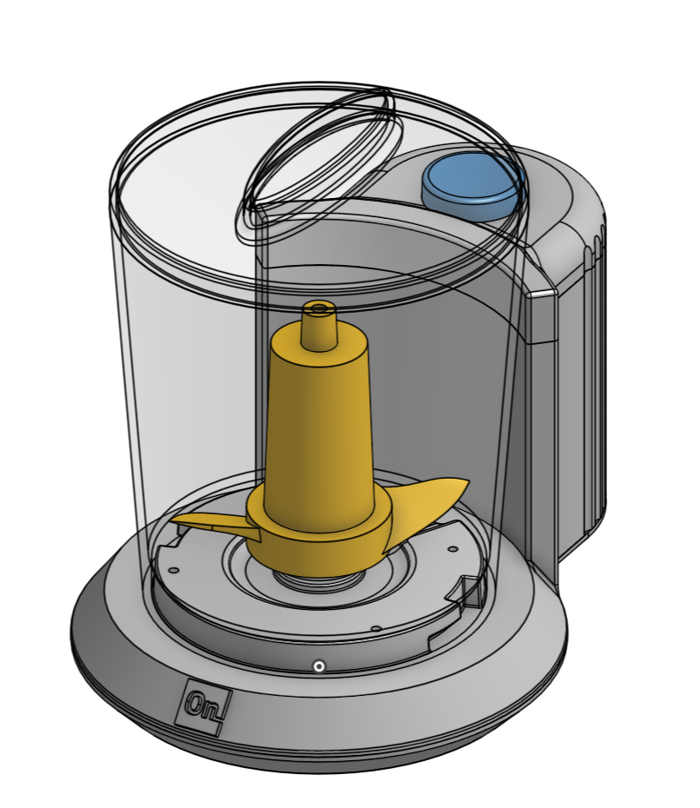

How cool is that?

1. Now, let’s save a version called “Final Design”. Our versions and history flyout should now look like this:

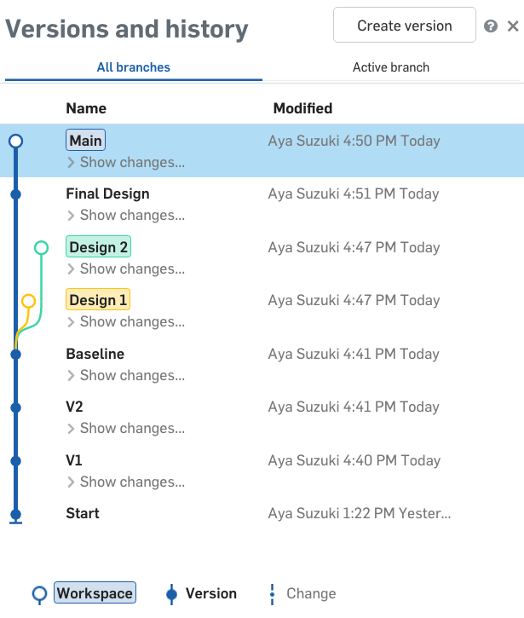

*Pro Tip: Be very careful when merging documents. Nothing will get deleted when two versions are merged, but a conflict may need to be addressed. For these situations, methodically go through any features that have turned red. Also, in the above lesson, we just compared the Part Studios for the changes, but in reality merging documents includes all tabs in the document. This means that if tabs have been removed in a Design Version, they will also be removed from any other version they are merged into! Attention to detail is needed at this stage to prevent a potential loss of work.*

1. Congratulations, you have now finished the Chopper design! Your part studio should now look like this:

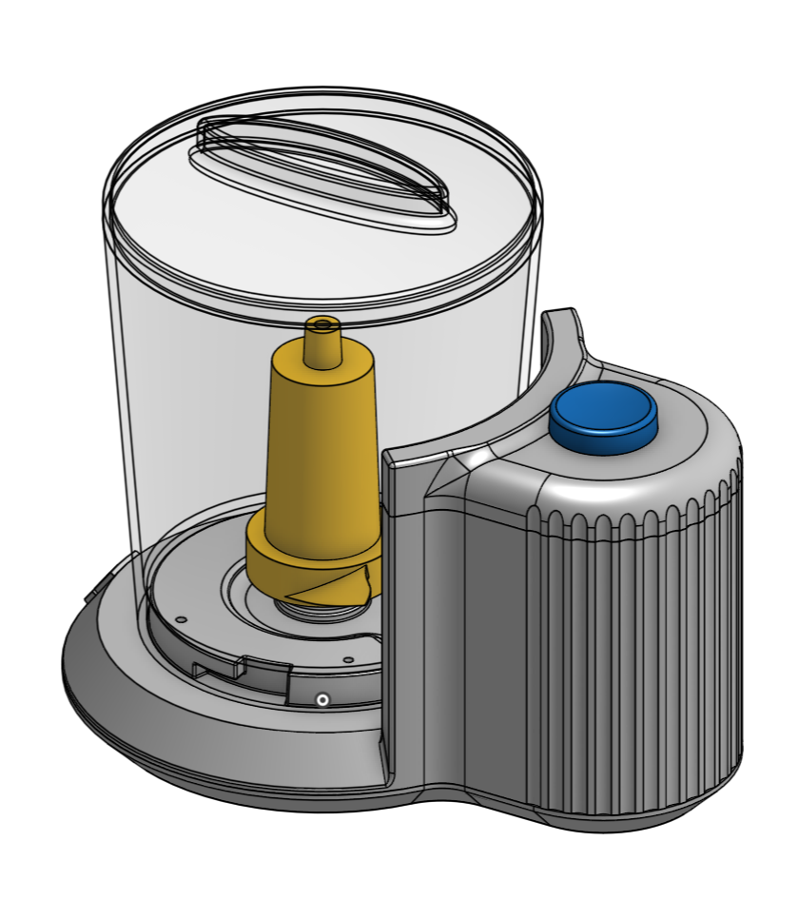

# Summary

Let’s take a second to reflect what we learned in this lesson.

1. We lofted three sketches to make a blade.
2. We used sketch splines to trace a logo and embossed it to our Chopper.
3. We learned how to make a spring by sweeping a circle along a helix.
4. We learned about branching, comparing, and merging, and merged two designs to create our final design!

Next week we will wrap up by adding motion in an assembly and touch on a few last, high-level topics.